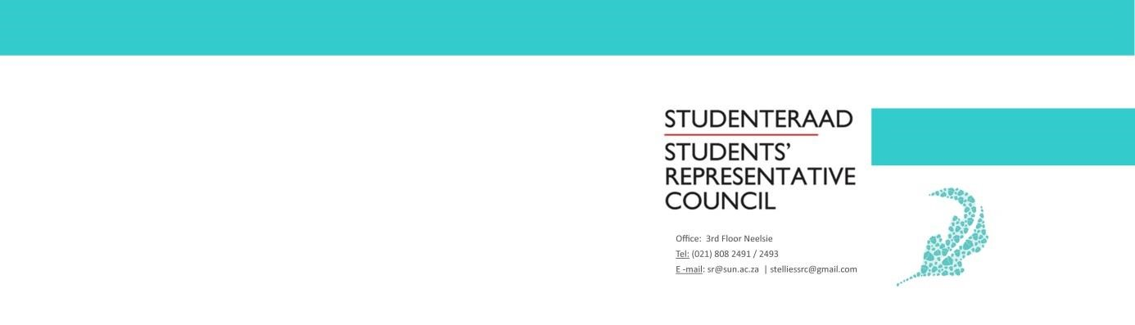

AGENDA
Students’ Representative Council Meeting
Date: 28 April 2020
Time: 14:00-16:00
Venue: Online

- Welcoming Lewis
- Attendance Fadeelah
- Approval of previous minutes Fadeelah
- Setting of the Agenda Fadeelah
- Discussion
  - Resolutions to issues raised in Internal Relations document Lewis and Wama
  - G2G Task Team Brandon
Brandon Murray, Treasurer, will present a full proposal including proof that the G2G Task Team will fulfil constitutional mandates of a Task Team
  - Initiative for Students Online Learning Jeff

  - Code of Conduct amendment regarding Meeting Recording Regulation
- Next Meeting Fadeelah
- Closing Lewis

